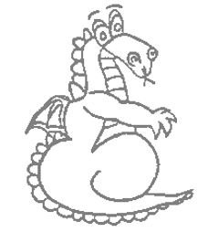 | VIPERS
Throughout KS2 we focus on the VIPER skills for reading. Here are some questions you could ask your child when reading a book with them.
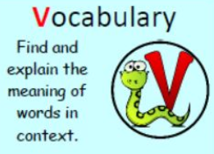 | Which of these words best describes the character/ setting/ mood?  What does the word ………….. mean in this sentence?  Can you think of other words the author could have used to mean a similar thing?  Which word tells you that …………?  Find one word in the text that means …………..?
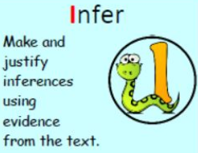 | Why was ………… feeling ……………..?  Why did ………………… say ……………………?  Why did………………happen?  Can you explain why …………..?  How do these words make you feel?  What was ………….. thinking when …………..?
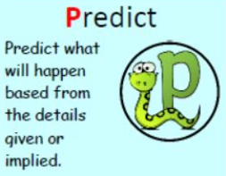 | What do you think this book will be about?  What do you think will happen next? What makes you think that?  What is happening now? What do you think happened before? What will happen after?  Do you think ……………….. will happen? Yes, no or maybe? Explain
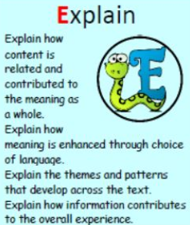 | Who is your favourite character? Why?  Would you like to live in this setting? Why/ why not?  Is there anything you would change about this book?  Do you like this text? What do you like about it?  Why is the text arranged in this way?  What is the author’s point of view?
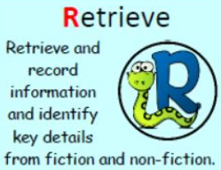 | What kind of text is this?  Who did …..? Where did ……….? What did ……….?  What happened when …………..?  Why did ………………… happen?  Give one example of………….  What can you learn from ……………… in this chapter?
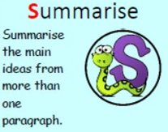 | What was the first thing that happened in the story?  What happened after …………..?  Can you summarise in a sentence the beginning/ middle/ end of the story?  What order did the events of this chapter happen?

